**ASSIGNMENT-26.5:**

How many kinds of tables are present in hive and explain the difference between them with a demo.

There are two types of tables in Hive:

* ***MANAGED TABLE :***
  + If a managed table is dropped, the data as well as the metadata are deleted.
* **EXTERNAL TABLE :**
  + If an external table is dropped, only metadata is deleted

Creating the Managed table:

Create a managed table named example.

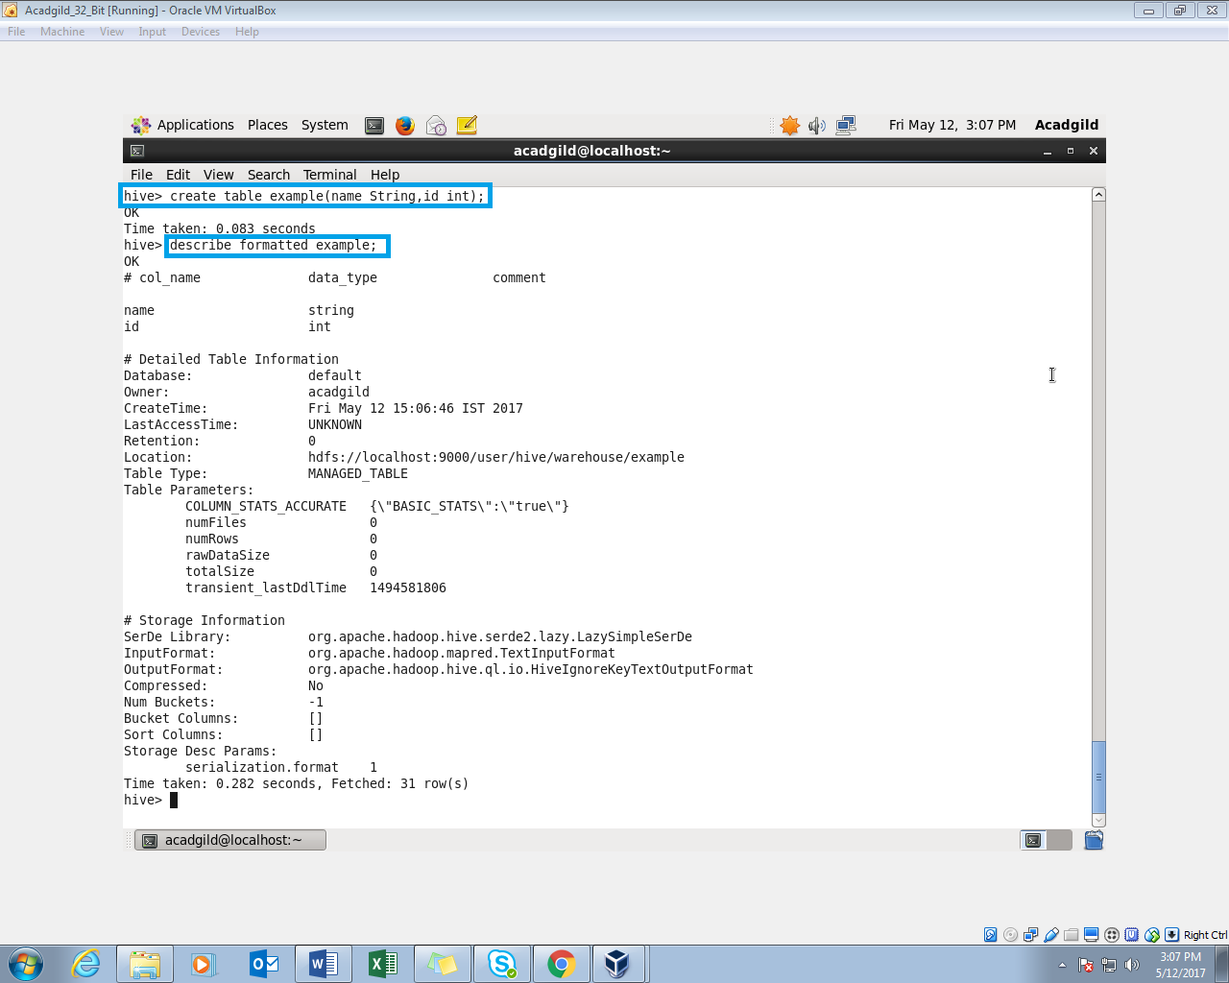

Dropping the managed table:

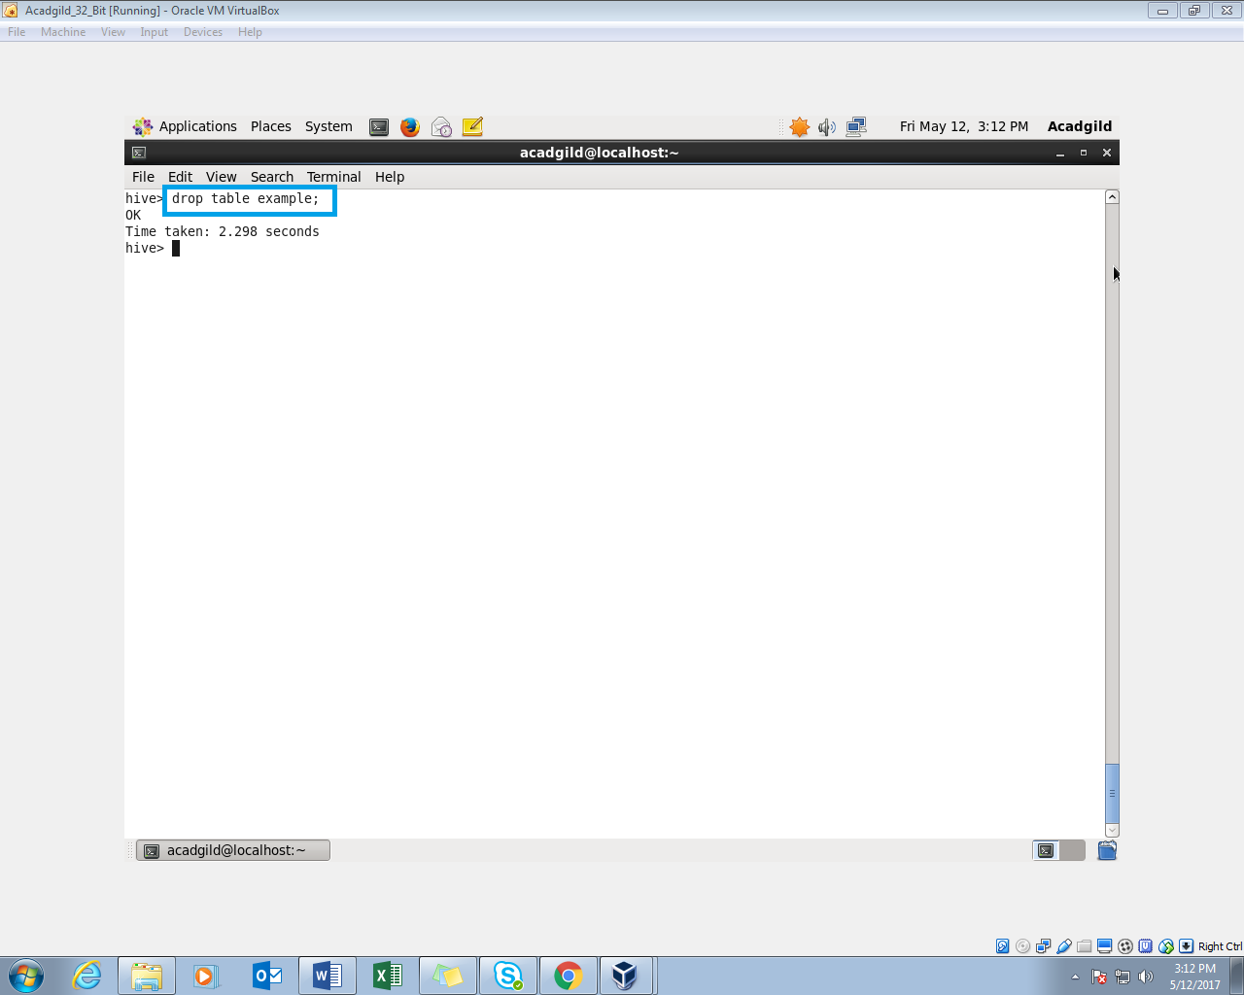

Creating the external table:

Create an external table named example1.

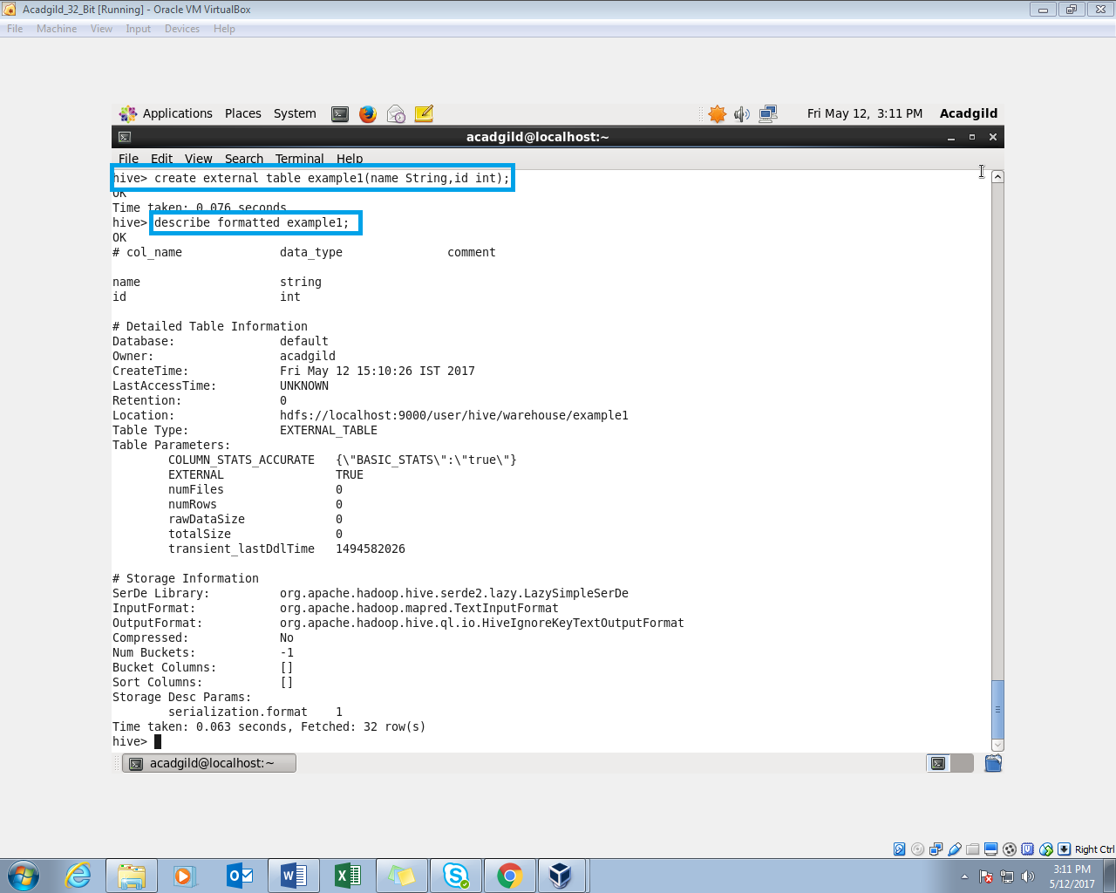

Dropping the external table:

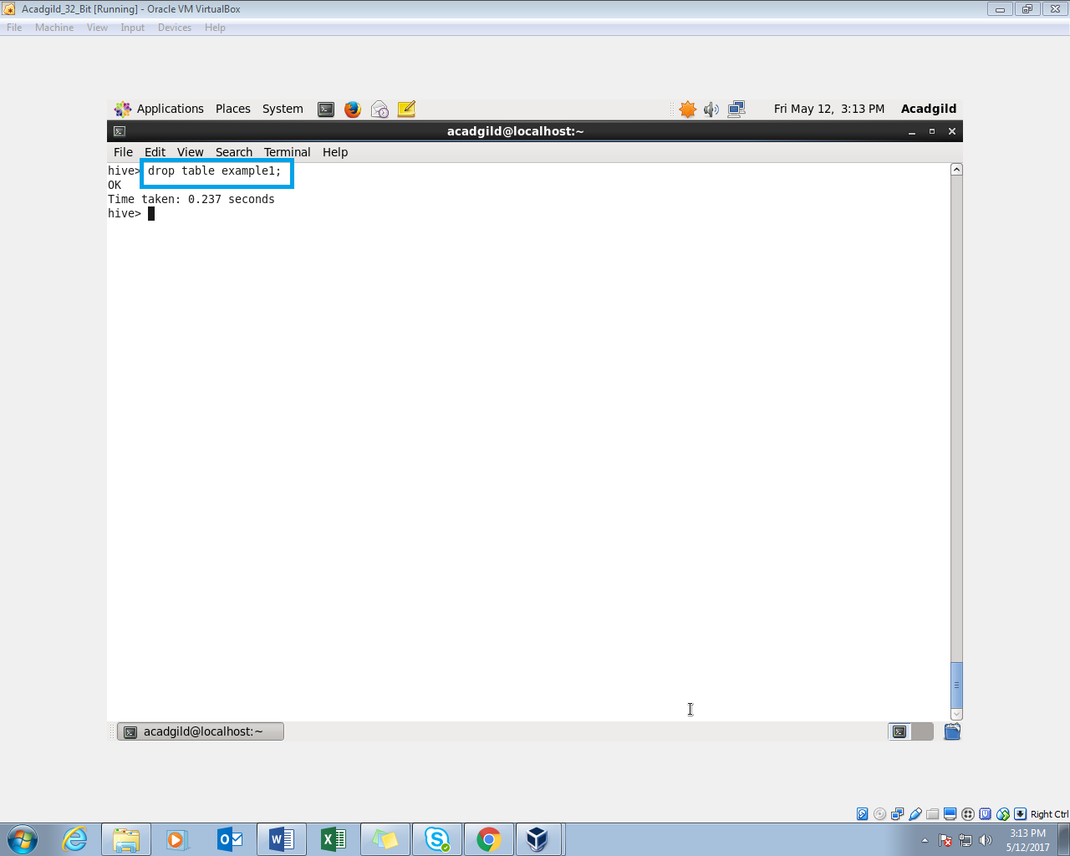

Displaying the directories:

We can see from the screenshot, the external table ‘example1’ is still present and the managed table ‘example’ is removed.

